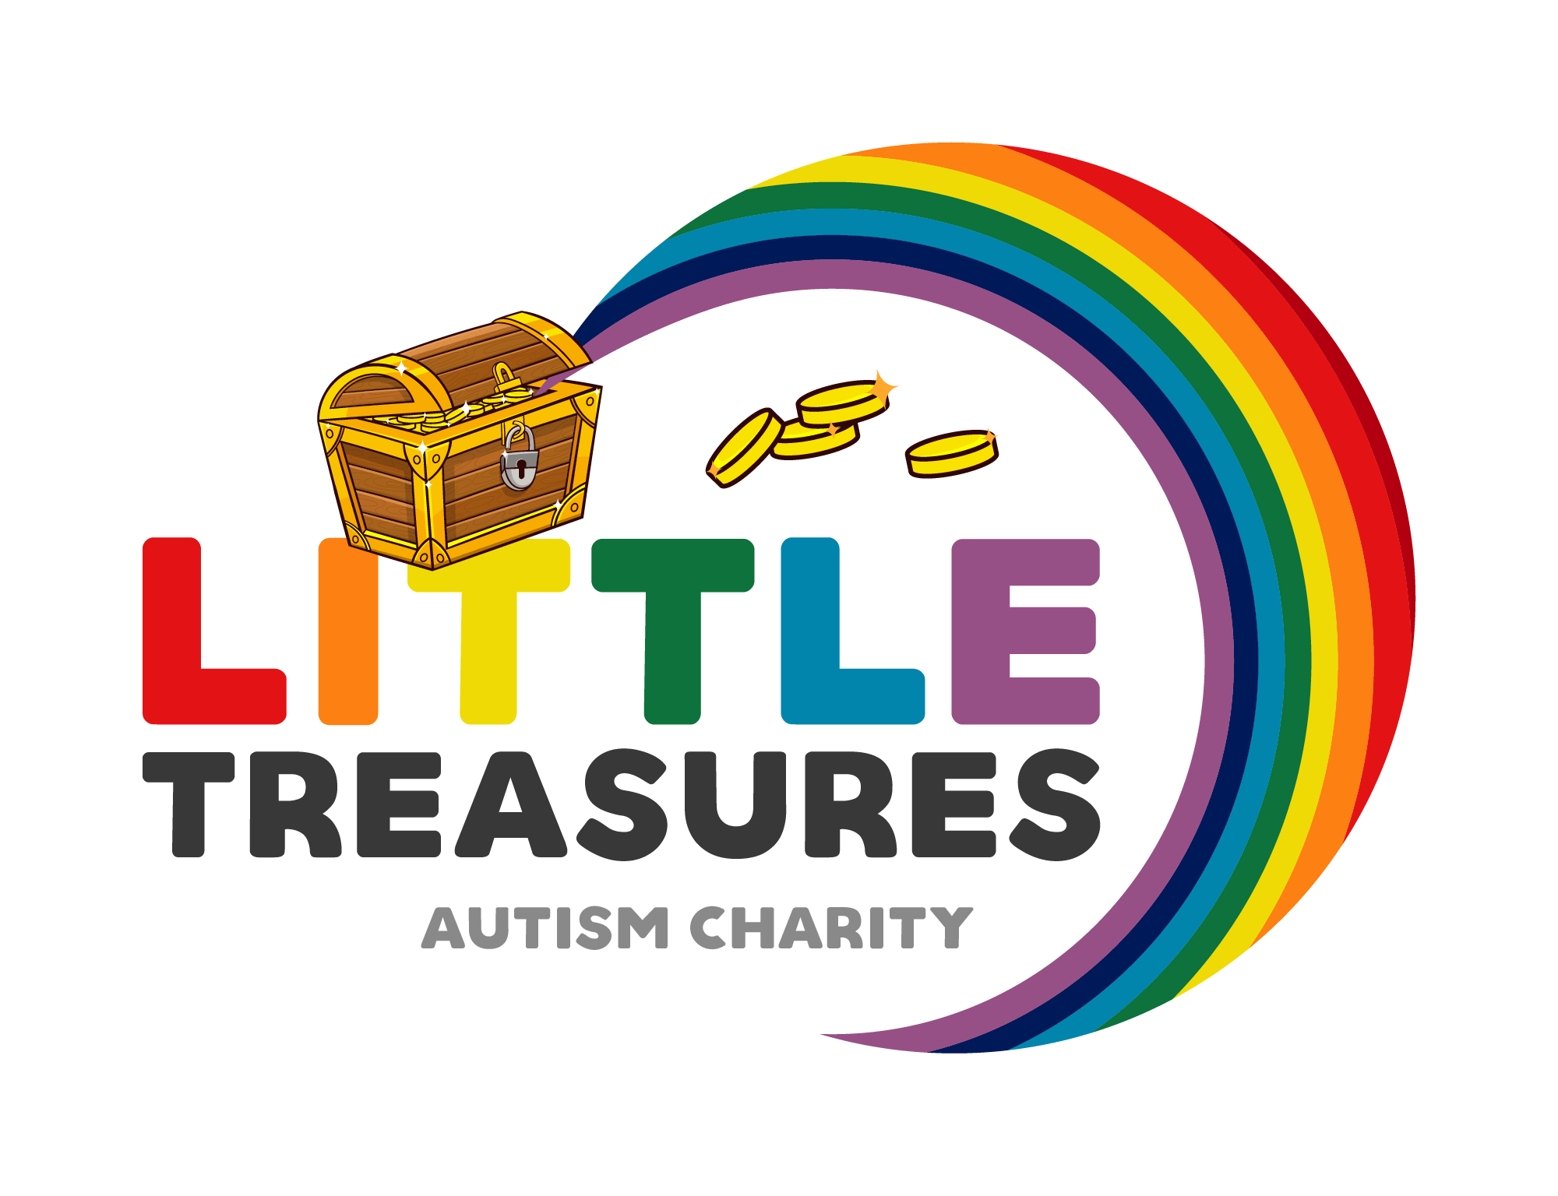
Little treasures autism charity
Registered charity number 1178397

SOCIAL MEDIA POLICY.

- PURPOSE

This social media policy provides guidance for all volunteers at little treasures autism charity. As a volunteer, you must follow this policy when…
- Advertising groups.
- Acting in a volunteer capacity, representing the charity.
- When engaging in social media activity outside of your volunteering role in a way that affects:
. Your performance
. The performance of other volunteers
. The charities aims and goals

- Guidelines for using social media on behalf of the charity.

Little treasures autism charity will be responsible for managing all of the charity’s main online social media accounts. Volunteers must always use the charities flyers/logo/brands when advertising on behalf of the charity. you must not rebrand flyers without the acknowledgment of a trustee. You must not share any details about members attending groups on social media (without consent) or any personal information about other volunteers (without consent) or anything discussed within groups/meetings/messages (without consent of all involved).
No screenshots of messages between volunteers/trustees/families are to be shared on any social media platforms or between other volunteers (in line with our confidentiality agreement). Any photos shared on behalf of the charity, consent must be provided from every person involved in the image (in line with our safe guarding policy).

