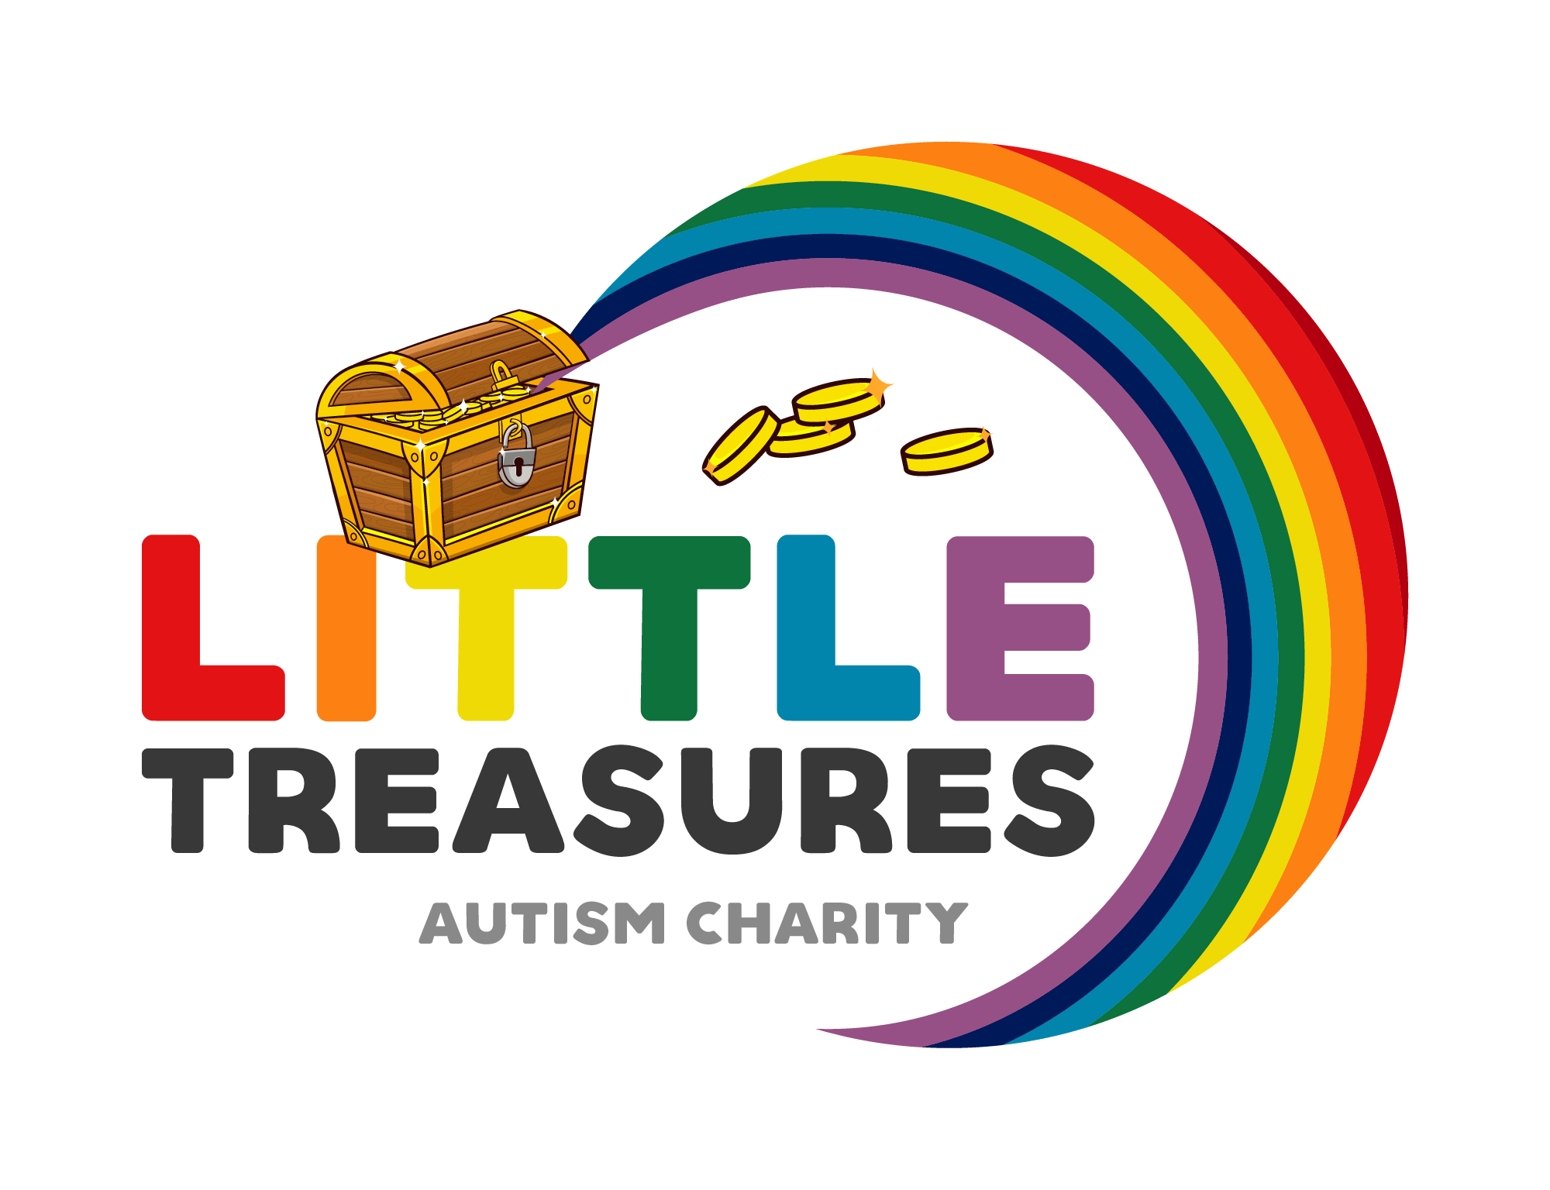
Little Treasures Autism Charity
Registered Charity Number 1178397
Safeguarding Policy
Little treasures autism Charity acknowledge the duty of care to safeguard and promote the welfare of children and is committed to ensuring safeguarding practise reflects statutory responsibilities, government guidance and complies with best practise.
The policy recognises that the welfare and interested of the children are paramount in all circumstances. It aims to ensure that regardless of age, ability or disability, gender reassignment, race or belief, sex or sexual orientation, socio-economic background, all children have a positive and enjoyable experience of play and social activities in a safe and child centred environment.
Little Treasures Autism Charity acknowledge that some children including disabled children and young people or those from ethnic minority communities, can be particularly vulnerable to abuse and we accept the responsibility to take reasonable and the appropriate steps to ensure their welfare whilst within our groups and social activities.
As part of our safeguarding policy Little Treasures Autism Charity will:
- Promote and prioritise the safety and well-being of children and young people.
- Ensure everyone understand their roles and responsibilities in respect of safeguarding and is provided with appropriate learning opportunities to recognise, identify, and respond to signs of abuse, neglect and other safeguarding concerns relating to children and young people.
- Ensure appropriate action is taken in event of incidents/concerns of any safeguarding issues and support been provided to the individual/s who has raised or disclose the concern.
- Ensure all information that is disclosed is treat confidential, detailed and accurate records of all safeguarding concerns and is maintained and stored securely.
- Check and follow up the session log.
- Report any concerns to Little Treasures Autism Charity safeguarding Officer details are below.
Clair Black
Email littletreasures18@gmail.com
Telephone Number 07470226736
The policy are procedures will be widely promoted and are mandatory for EVERYONE at Little Treasures Autism Charity. Failure to comply with the above policy and procedures the Trustees will suspend any volunteer/s or families at any groups until there has been an investigation and all reports have been received, the trustees will met and discuss it further. All outcomes will be received in a formal written statement.
Monitoring.
The policy will be reviewed yearly by the Charity’s Safeguarding Officer and then every 3 years or in the following circumstances:
- Changes in legislation and/or government guidance
- Or as a result of any other significant changes or event

