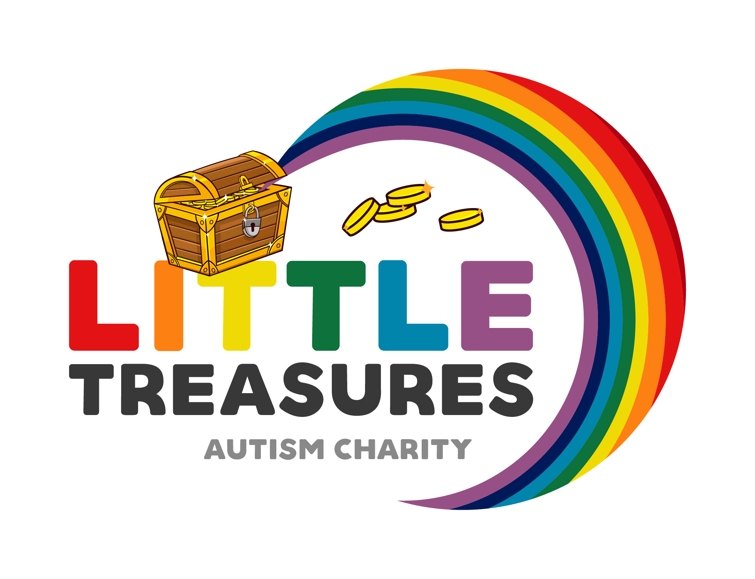

Little Treasures Equality Policy

Aims

Little Treasures aims to help autistic families to have an atmosphere of friendship, respect, and care for each other. We aim to treat every family equally, regardless of their age, disability, gender reassignment, marriage or civil partnership, pregnancy or maternity, race, religion or belief, sex, or sexual orientation.

Accessibility

All our meetings and events are held in venues that are accessible to wheelchair users.
When we organize outings for our members, we provide discounted spaces for carers of members who can only attend if they bring a carer. We offer all our autistic families discounted prices as everyone have a child or family member with a disability.
We are committed to ensuring as many families can attend our activities, so we will reassess our access requirements to meet the needs of new families.

Diversity
We aim to organize a range of events and activities to suit the interests and meet the needs of a wide variety of people.
For example, we hold parties for Christmas which are inclusive to any individual with a disability.
Little Treasures are open to new ideas to meet the needs of as many families as possible.

Inclusion and respect
Every family of Little Treasures should be made to feel equally welcome and included at all meetings and events we hold.
Sexist, racist, homophobic, transphobic, or otherwise offensive and inflammatory remarks and behavior are not acceptable. These constitute harassment and have no place in our charity.

Dealing with discrimination and harassment
If any family feel they have been discriminated against by the charity at any event they should raise this with the trustees.
The trustees will investigate the complaint, listening to all members involved.
Any decision to exclude a person from the charity due to discriminatory or harassing behavior will be made with reference to the charity constitution.
The charity will support people who feel they have been harassed or discriminated against and will not victimize them because they have raised this.
This policy will be reviewed every 2 years, last review – 1/01/2024.

